# Changing Source Data Location

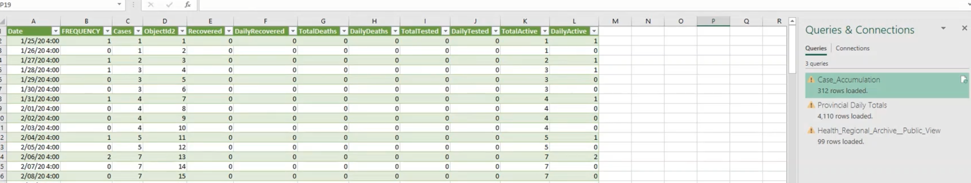

* For example this one you can see on the right side that there are some alerts/errors
* If you hover over one of the queries you will see it will give you a description of the error

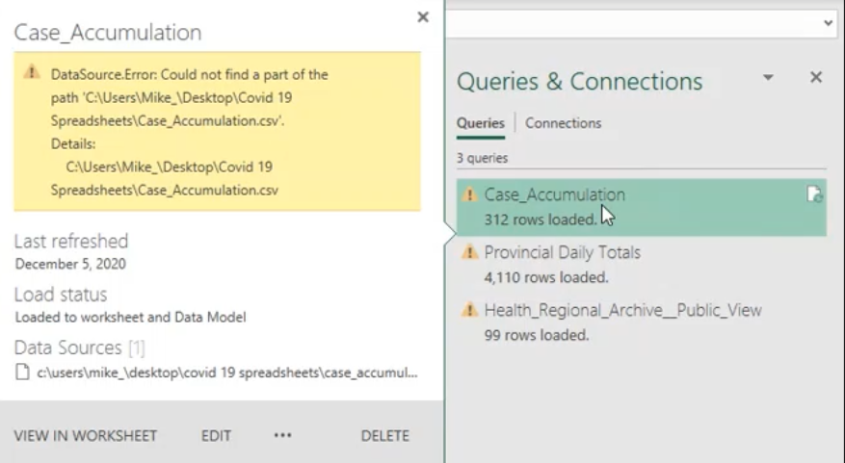

* Excel is trying to look in that pathway. You can recreate that pathway or you can repoint this query to look in a different place

Steps

1. Open up the query with the error
2. Click on the yellow banner “Go To Error”
3. Click on Home > Data Source Settings

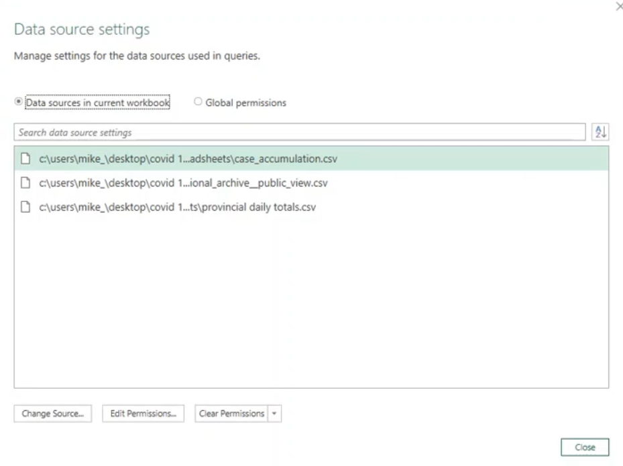

1. You can see the different source files. Highlight the pathway you want to edit. You can click on Change Source..

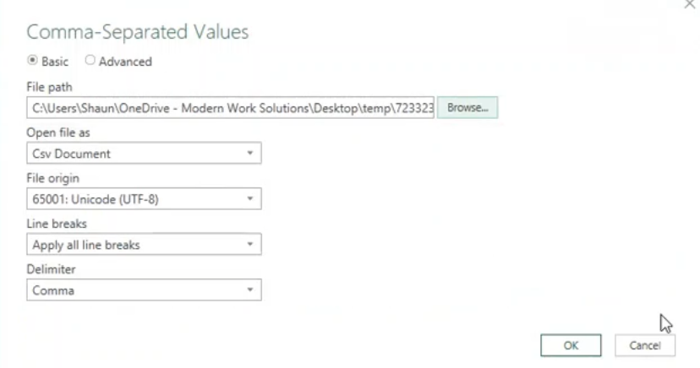

1. Then change the other files as well as needed to fix the pathway.
2. Then go to Home > Close & Load
3. You will see all the errors should be gone now that you properly linked the file path